Vehicle Fuel Efficiency Prediction System

PROFESSIONAL TRAINING - 2
at
Sathyabama Institute of Science and Technology (Deemed to be University)

Submitted in partial fulfillment of the requirements for the award of Bachelor of Engineering degree in Computer Science and Engineering

By
KARTBYA KUMAR (Reg. No – 43110402)



DEPARTMENT OF COMPUTER SCIENCE ENGINEERING SCHOOL OF COMPUTING

SATHYABAMA
INSTITUTE OF SCIENCE AND TECHNOLOGY (DEEMED TO BE UNIVERSITY)
CATEGORY- 1 UNIVERSITY BY UGC
Accredited “A++” by NAAC I Approved by AICTE JEPPIAAR NAGAR, RAJIV GANDHI SALAI CHENNAI - 600119

OCTOBER - 2026


DEPARTMENT OF COMPUTER SCIENCE AND ENGINEERING

BONAFIDE CERTIFICATE

This is to certify that this Professional Training-2 Report is the bona-fide work of KARTBYA KUMAR (43110402) who carried out the Project entitled “Vehicle Fuel Efficiency Prediction System” under my supervision from January 2026 to May 2026.

Internal Guide
Dr.G.Subhathra,

Head of the Department
Dr. L. LAKSHMANAN, M.E., Ph.D.,

Submitted for Professional Training project Viva Voce Examination held on

Internal Examiner External Examiner

DECLARATION
I, KARTBYA KUMAR (Reg. No- 43110402), hereby declare that the Professional Training-2 Report entitled “Vehicle Fuel Efficiency Prediction System” done by me under the guidance of Dr. G Subhatra , Ph.D., is submitted in partial fulfillment of the requirements for the award of Bachelor of Engineering degree in Computer Science and Engineering.

DATE:

PLACE: Chennai SIGNATURE OF THE CANDIDATE

ACKNOWLEDGEMENT

I am pleased to acknowledge my sincere thanks to BOARD OF MANAGEMENT of Sathyabama Institute of Science and Technology for their kind encouragement in doing this project and for completing it successfully. I am grateful to them.
I convey my thanks to Dr. L. Lakshmanan, M.E., Ph.D., Dean & HoD., School of Computing, Department of Computer Science and Engineering for providing me with necessary support and details at the right time during the progressive reviews.
I would like to express my sincere and deep sense of gratitude to my Project Guide Dr.G.Subathra. for his valuable guidance, suggestions, and constant encouragement paved the way for the successful completion of my project work.
I wish to express my thanks to all Teaching and Non-teaching staff members of the Department of Computer Science and Engineering who were helpful in many ways for the completion of the project.

TRAINING CERTIFICATE

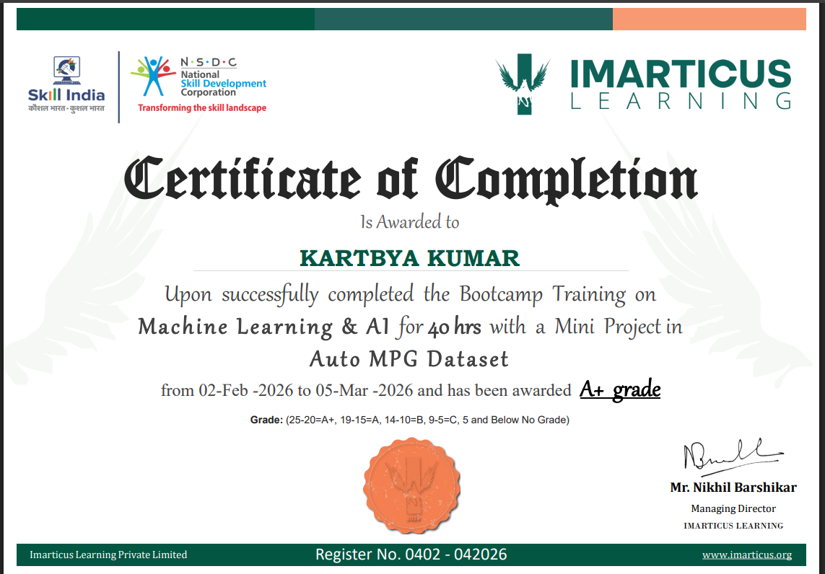

ABSTRACT
The Vehicle Fuel Efficiency Prediction System is a machine learning–based application designed to estimate a vehicle’s fuel efficiency (measured in miles per gallon, MPG) using key automobile attributes such as number of cylinders, engine displacement, horsepower, weight, acceleration, model year, and origin. In the automotive industry, evaluating fuel efficiency manually or through traditional testing methods can be time-consuming, costly, and resource-intensive. This system addresses these challenges by providing a data-driven, automated solution for accurate fuel efficiency prediction.
The application leverages historical vehicle datasets to train regression models capable of identifying patterns and relationships between vehicle characteristics and fuel consumption. Advanced data preprocessing techniques, including handling missing values, normalization, and feature selection, are applied to improve model performance. Multiple machine learning algorithms such as Linear Regression, Decision Trees, and Random Forest are implemented and compared to achieve optimal prediction accuracy.
The system is designed with a user-friendly interface where users can input vehicle specifications and instantly receive predicted MPG values. The backend handles model training, evaluation, and prediction logic, while the frontend ensures accessibility and ease of use. Visualization tools are also integrated to provide insights into feature importance and model performance.
By automating fuel efficiency prediction, this project demonstrates how machine learning can assist manufacturers, researchers, and consumers in making informed decisions regarding vehicle design and selection. The system is scalable and can be further enhanced by integrating real-time data, hybrid models, and deployment as a web or mobile application.

TABLE OF CONTENTS

CHAPTER No. | TITLE | PAGE No.
 | ABSTRACT | vi
 | LIST OF FIGURES | viii
1 | INTRODUCTION | 1
 | 1.1 BACKGROUND | 1
 | 1.2 OVERVIEW
 | 1.3 PURPOSE OF THE SYSTEM | 2
 | 1.4 SCOPE OF THE PROJECT
 | 1.5 OBJECTIVES OF THE SYSTEM | 3
2 | SYSTEM ANALYSIS | 4
 | 2.1 INTRODUCTION TO SYSTEM ANALYSIS | 4
 | 2.2 EXISTING SYSTEM ANALYSIS
 | 2.3 LIMITATIONS OF EXISTING SYSTEM
 | 2.4 PROPOSED SYSTEM ANALYSIS | 5
 | 2.5 FEASIBILITY STUDY
 | 2.6 REQUIREMENTS ANALYSIS | 5
 | 2.7 SYSTEM MODELS AND FLOW
3 | METHOD AND IMPLEMENTATION | 6
 | 3.1 INTRODUCTION | 6
 | 3.2 USER INPUT MODULE
 | 3.3 DATA PREPROCESSING MODULE | 7
 | 3.4 MODEL TRAINING MODULE
 | 3.5 PREDICTION MODULE
 | 3.6 MODEL EVALUATION MODULE | 8
 | 3.7 SYSTEM INTEGRATION | 9
4 | RESULTS & DISCUSSION | 10
 | 4.1 INTRODUCTION | 10
 | 4.2 SYSTEM FUNCTIONALITY RESULTS
 | 4.3 USER INTERACTION AND EXPERIENCE | 11
 | 4.4 PERFORMANCE ANALYSIS
 | 4.5 PREDICTION RESULTS | 12
 | 4.6 MODEL EVALUATION AND ANALYSIS
 | 4.7 DISCUSSION
 | 4.8 SUMMARY | 13
5 | CONCLUSION | 14
 | 5.1 CONCLUSION | 14
 | 5.2 FUTURE ENHANCEMENTS | 15
 | REFERENCES | 16

 | LIST OF FIGURES
FIG NO | FIGURES | PAGE NO.
3.2 | USER INPUT INTERFACE | 6
3.5 | FUEL EFFICIENCY PREDICTION RESULT | 8
3.7 | DATA VISULIZATION DASHBOARD | 9

CHAPTER 1 INTRODUCTION

1.1 BACKGROUND
In recent years, the rapid growth of the automotive industry has led to an increased demand for fuel-efficient vehicles. With rising fuel costs and growing environmental concerns such as carbon emissions and global warming, understanding and improving vehicle fuel efficiency has become a critical area of focus. Traditionally, fuel efficiency is measured through physical testing and standardized procedures, which can be time-consuming, expensive, and sometimes impractical for large-scale analysis.
Advancements in machine learning and data analytics have opened new possibilities for predicting vehicle performance using historical data. By analyzing various attributes such as engine specifications, weight, and design parameters, it is possible to estimate fuel efficiency accurately without the need for extensive real-world testing. This approach not only reduces cost and effort but also enables faster decision-making for manufacturers and consumers.
This project highlights the importance of data-driven approaches in solving real-world problems and demonstrates how predictive modeling can enhance efficiency, support sustainable practices, and contribute to smarter automotive design.

1.2 OVERVIEW
The Volunteer Management System, also known as Volunteer Hub, is designed to address the limitations of traditional volunteer management methods by providing a comprehensive digital solution. The system acts as a centralized platform that connects volunteers and administrators, enabling efficient coordination of events and activities.
Through this system, users can register, create profiles, and participate in events based on their interests. Administrators are provided with tools to create and manage events, track volunteer participation, and analyze system performance. The system ensures that all data related to users, events, and participation is stored securely and can be accessed easily when required.
The application is developed using modern technologies that support scalability, reliability, and performance. The backend is responsible for handling business logic and processing user requests, while the frontend provides an interactive interface for users.

1.3 PURPOSE OF THE SYSTEM
The primary purpose of the Vehicle Fuel Efficiency Prediction System is to simplify and automate the process of estimating vehicle fuel efficiency using a machine learning–based approach. The system aims to replace traditional testing and manual calculations with an efficient digital platform that improves accuracy and reduces the time required for analysis.
By providing features such as real-time prediction, analysis of vehicle parameters, and model evaluation, the system enhances the overall experience for users and developers. It ensures that users can easily input vehicle details, obtain accurate MPG predictions, and understand fuel efficiency trends. At the same time, the system enables better decision-making by providing reliable data-driven insights for vehicle selection and design.

1.4 SCOPE OF THE PROJECT
The scope of this project includes the development of a full-stack machine learning–based application that supports various functionalities related to vehicle fuel efficiency prediction. The system allows users to input vehicle parameters, obtain predicted fuel efficiency (MPG), and view analysis results through an interactive interface. It also enables the storage of prediction history and visualization of data for better understanding.
The system is designed to handle multiple user inputs efficiently and ensure smooth operation under different conditions. It can be extended in the future to include features such as mobile application support, real-time data integration, advanced analytics, and deployment on cloud platforms. The scalability of the system ensures that it can be used for research, automotive analysis, and decision-making across different use cases.

1.5 OBJECTIVES OF THE SYSTEM
The development of the Vehicle Fuel Efficiency Prediction System is guided by several key objectives. The system aims to provide a centralized and intelligent platform for predicting vehicle fuel efficiency efficiently. It focuses on automating the prediction process using machine learning techniques to reduce manual effort and improve accuracy.

CHAPTER 2
SYSTEM ANALYSIS
2.1 INTRODUCTION TO SYSTEM ANALYSIS
System analysis is a crucial phase in the software development lifecycle that focuses on understanding the requirements, identifying problems in the existing system, and proposing an effective solution. In the context of the Vehicle Fuel Efficiency Prediction System, this phase involves studying the limitations of traditional fuel efficiency estimation methods and designing a system that addresses those limitations through automation and data-driven techniques.
The analysis phase helps in identifying the functional and non-functional requirements of the system. It ensures that the system being developed provides accurate predictions and performs efficiently under different conditions. By clearly defining system requirements, the development process becomes more structured and reduces the chances of errors during implementation.

2.2 EXISTING SYSTEM ANALYSIS
In most organizations, volunteer management is handled using manual methods or simple digital tools that lack integration. Volunteer data is often stored in spreadsheets or maintained using paper-based records. Event details are communicated through emails or messaging platforms, and attendance is recorded manually during events.
This approach leads to several inefficiencies. Data is scattered across multiple sources, making it difficult to maintain consistency. Manual entry of information increases the chances of errors, such as duplicate records or incorrect data. Communication between volunteers and administrators is often delayed, leading to confusion and missed opportunities.
Another major limitation of the existing system is the lack of real-time tracking. Administrators are unable to monitor volunteer participation effectively, and volunteers do not receive timely updates about events. Additionally, there is no proper mechanism for collecting feedback or analyzing performance, which limits the ability to improve future activities.

2.3 LIMITATIONS OF EXISTING SYSTEM
The existing system for estimating vehicle fuel efficiency suffers from several drawbacks that affect overall efficiency and accuracy. The absence of an automated and centralized approach results in fragmented data handling, making it difficult to access, process, and analyze vehicle-related information effectively. Traditional methods require significant time and manual effort, which reduces productivity.
The system also lacks precision, as manual calculations and basic testing methods do not fully capture the complex relationships between various vehicle attributes. This can lead to inaccurate or inconsistent results. Additionally, there is limited accessibility, as users cannot easily obtain fuel efficiency estimates without performing detailed analysis or physical testing.
Another major limitation is the lack of real-time prediction and advanced analytics. Existing methods do not support quick evaluation of multiple input parameters or comparison of different predictive models. Scalability is also a concern, as handling large datasets and repeated computations becomes increasingly difficult and error-prone.

2.4 PROPOSED SYSTEM ANALYSIS
The proposed Vehicle Fuel Efficiency Prediction System introduces a fully automated and centralized platform for predicting vehicle fuel efficiency using machine learning techniques. It integrates various functionalities such as data preprocessing, model training, prediction, visualization, and result storage into a single system.
The system allows users to input vehicle parameters such as cylinders, displacement, horsepower, weight, acceleration, model year, and origin, enabling accurate prediction of fuel efficiency (MPG). The machine learning model processes these inputs and generates results based on patterns learned from historical data, making the prediction process faster and more reliable.
Real-time prediction capabilities ensure that users receive instant results, improving usability and efficiency. Visualization features help users understand the relationship between different vehicle attributes and fuel efficiency. Additionally, the system stores prediction results, enabling analysis and better decision-making.
By automating these processes, the system reduces manual effort, improves accuracy, and enhances overall efficiency in fuel efficiency prediction and analysis.

2.5 FEASIBILITY STUDY
The feasibility study evaluates whether the proposed Vehicle Fuel Efficiency Prediction System can be successfully implemented.
From a technical perspective, the system is feasible because it uses widely available technologies such as Python, machine learning libraries (Pandas, NumPy, Scikit-learn), and web frameworks like Flask. These technologies are reliable, scalable, and well-supported by the developer community.
The system is also feasible in terms of time, as it can be developed and deployed within a reasonable timeframe using standard machine learning and software development practices.

2.6 REQUIREMENTS ANALYSIS
The system requirements are categorized into functional and non-functional requirements.
The functional requirements define the core functionalities of the system. These include user input of vehicle parameters, data preprocessing, fuel efficiency prediction using machine learning models, result display, data visualization, and storage of prediction history. Each of these functionalities is essential for the proper operation of the system and ensures accurate and efficient prediction.
The non-functional requirements define the quality attributes of the system. These include performance, scalability, accuracy, security, and usability. The system must be able to process inputs and generate predictions quickly without performance degradation. It should also ensure reliable data handling and secure storage of prediction records. Additionally, the interface should be user-friendly and accessible to users with different levels of technical knowledge, ensuring ease of use and smooth interaction.

2.7 SYSTEM MODELS AND FLOW
The overall workflow of the Vehicle Fuel Efficiency Prediction System begins with user input, where users provide vehicle details such as cylinders, displacement, horsepower, weight, acceleration, model year, and origin. Once the data is entered, it is validated and processed to ensure accuracy and consistency.
The system also includes visualization features, where users can view graphical representations of relationships between different variables such as horsepower and MPG or weight and MPG. This helps in better understanding the data patterns and model behavior.
This structured flow ensures smooth operation, accurate prediction, and efficient data processing within the system.
.

CHAPTER-3
METHOD AND IMPLEMENTION
3.1 INTRODUCTION
After preprocessing, the input data is passed to the trained machine learning model, which analyzes the parameters and generates a prediction of fuel efficiency (MPG). The predicted result is then displayed to the user through the interface in a clear and understandable format. At the same time, the prediction data is stored in the database, allowing it to be retrieved later for analysis, comparison, and future reference.

3.2 USER INPUT MODULE
The user input module allows users to interact with the system by entering vehicle details required for fuel efficiency prediction. Users provide input parameters such as number of cylinders, displacement, horsepower, weight, acceleration, model year, and origin. The system performs input validation to ensure that all required fields are filled correctly and within acceptable ranges.
Once the data is validated, it is processed and passed to the machine learning model for prediction. This module plays a crucial role in ensuring accurate results by maintaining data consistency and correctness. It also serves as the primary interface through which users interact with the system and obtain fuel efficiency predictions.
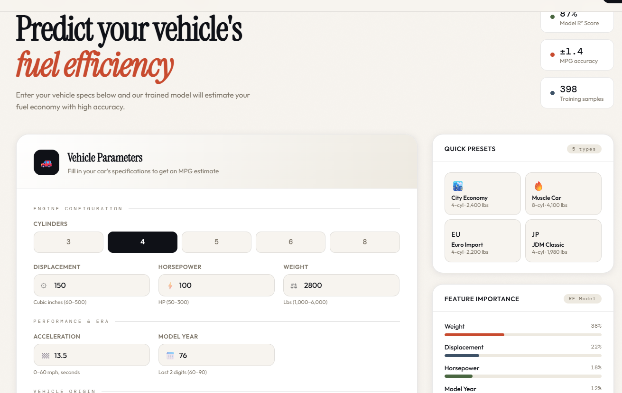
Fig 3.2 USER INPUT MODULE

3.3 DATA PREPROCESSING MODULE
The data preprocessing module is responsible for preparing the dataset before it is used for prediction. It involves handling missing values, removing duplicate records, and converting data into a suitable format for the machine learning model. The system also performs normalization and transformation of features to improve model performance.
This module ensures that the input data is clean, and reliable, which is essential for accurate prediction. It also helps in identifying and correcting inconsistencies in the dataset, thereby improving the overall quality of the system. By preparing the data effectively, this module supports smooth functioning of the prediction process.

3.4 MODEL TRAINING MODULE
The model training module is responsible for developing and training the machine learning model using the preprocessed dataset. In this phase, appropriate algorithms such as Linear Regression and Random Forest are selected to learn the relationship between vehicle attributes and fuel efficiency (MPG). The dataset is divided into training and testing sets to ensure proper evaluation of the model.
During training, the model analyzes patterns in the data and adjusts its parameters to improve prediction accuracy. Various techniques such as feature selection and parameter tuning are applied to enhance model performance. The trained model is then validated using test data to check its reliability and effectiveness.
This module plays a critical role in the system, as the accuracy of predictions depends on how well the model is trained. A well-trained model ensures consistent and reliable results, making the system more efficient and dependable for fuel efficiency prediction.

3.5 PREDICTION MODULE
The prediction module provides access to the core functionality of the system by processing user input and generating fuel efficiency results. Users can initiate the prediction by submitting vehicle parameters through the interface. The system verifies the input data and passes it to the trained machine learning model for analysis.
This module ensures accurate and efficient prediction of fuel efficiency (MPG) based on the given inputs. It also displays the results clearly to the user and may store them for future reference. The module plays a key role in delivering the primary objective of the system by enabling fast and reliable predictions

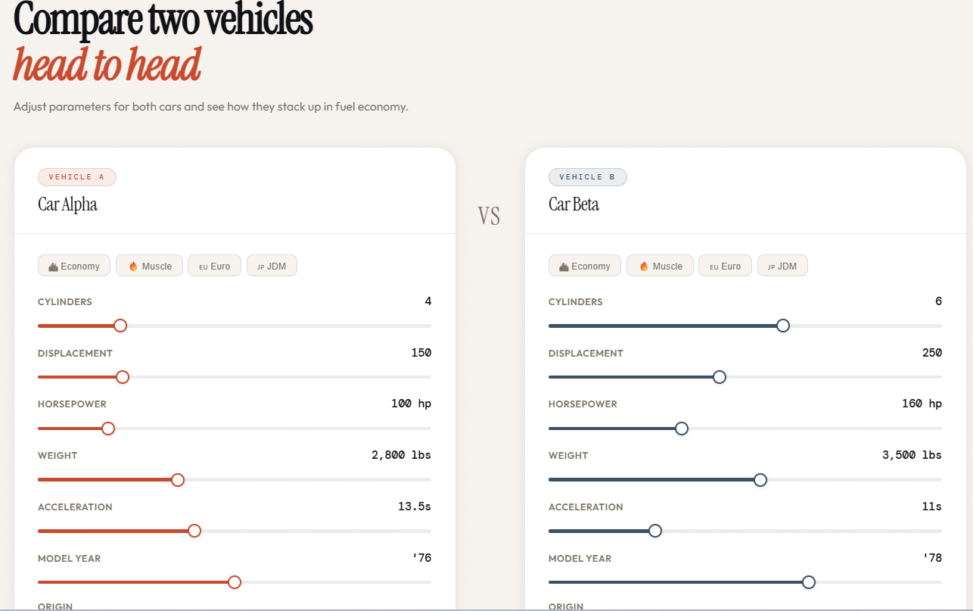

Fig 3.5 PREDICTION RESULT

3.6 MODEL EVALUATION MODULE
The model evaluation module is responsible for assessing the performance of the machine learning model used for fuel efficiency prediction. It evaluates how accurately the model predicts MPG values by comparing predicted results with actual data.
The system uses evaluation metrics such as Mean Absolute Error (MAE), Mean Squared Error (MSE), and R-squared values to measure performance. These metrics help in understanding the accuracy and reliability of the model. This module also allows comparison of different algorithms to select the most suitable one.
This feature ensures that the model performs efficiently and provides reliable predictions. It also helps in improving the system by identifying areas where the model can be optimized for better accuracy.

3.7 SYSTEM INTEGRATION MODULE
The system integration module provides a centralized control mechanism for managing the overall operation of the Vehicle Fuel Efficiency Prediction System. It integrates different components such as the user interface, machine learning model, and database to ensure smooth data flow and functionality.
This module allows the system to handle user inputs, process data through the trained model, and display prediction results efficiently. It also manages the storage of prediction data for future reference and analysis. By coordinating all modules effectively, this component ensures reliable system performance and seamless interaction between different parts of the application.

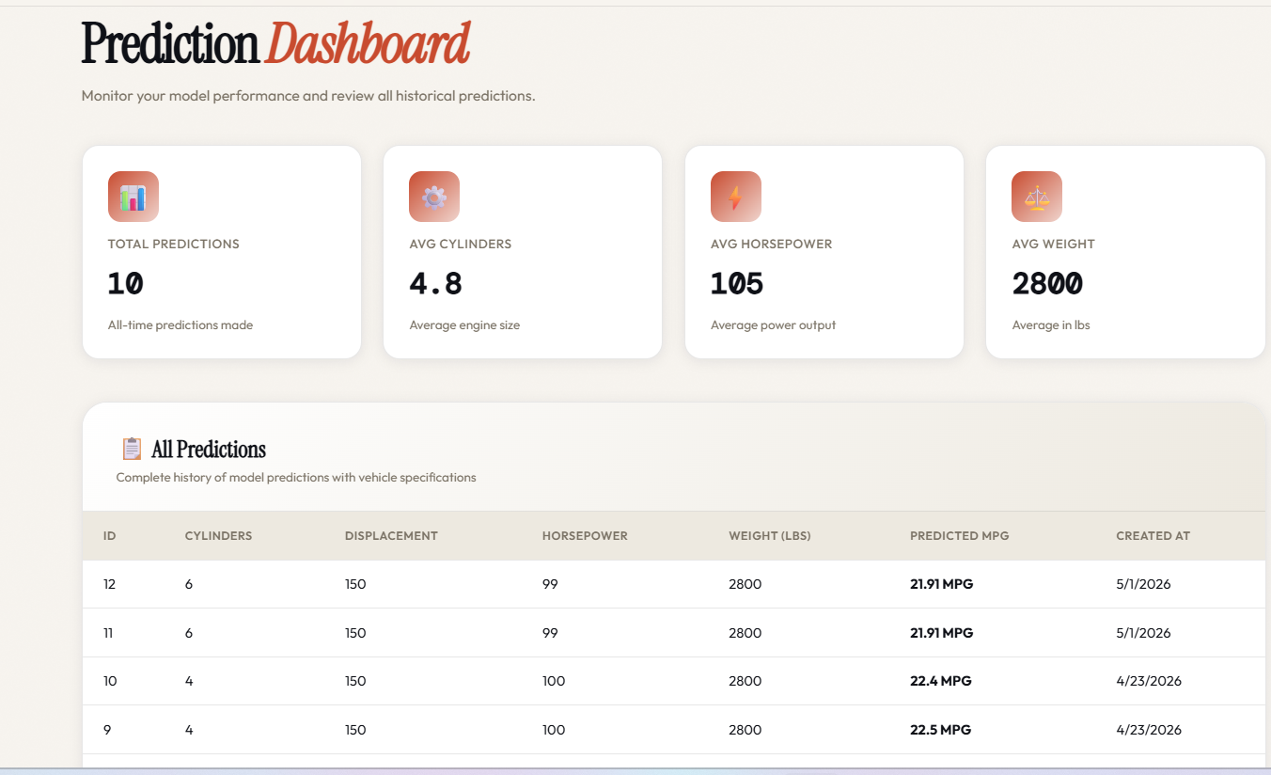

CHAPTER-4
RESULTS & DISCUSSION
4.1 INTRODUCTION
The results and discussion phase is an important part of the project as it evaluates the performance and effectiveness of the developed system. This chapter presents the outcomes obtained after implementing the Vehicle Fuel Efficiency Prediction System and analyzes how well the system meets the intended objectives. The evaluation focuses on prediction accuracy, system functionality, user interaction, and overall efficiency.
The system was tested using different input values and datasets to ensure that all modules operate correctly and produce the expected output. The results demonstrate how the system performs in real-time scenarios and how effectively it handles data processing and prediction tasks.

4.2 SYSTEM FUNCTIONALITY RESULTS
The implemented system successfully performs all the core functions required for vehicle fuel efficiency prediction. Users are able to input vehicle parameters without any difficulty, and the system validates the entered data to ensure correctness and completeness. The input process is simple and efficient, allowing smooth interaction with the system.
The prediction functionality works effectively by processing the input data through the trained machine learning model and generating accurate fuel efficiency (MPG) values. The results are displayed clearly to the user, ensuring easy understanding. The system ensures that all prediction operations are performed correctly and consistently.
Additionally, the system supports data visualization and result storage. Graphs and charts are generated to help users understand the relationship between different vehicle attributes and fuel efficiency. The prediction data can also be stored for future reference and analysis. Overall, the system operates reliably and fulfills its intended functionalities without errors.

4.3 USER INTERACTION AND EXPERIENCE
The system provides a user-friendly interface that enhances the overall user experience. The layout is simple and intuitive, allowing users to easily enter vehicle details and navigate through different sections of the application. Clear labels and well-structured input fields help users understand the functionality of each component.
Users are able to perform tasks such as entering vehicle parameters, generating predictions, and viewing results without requiring advanced technical knowledge. The interface is designed to minimize complexity and ensure smooth interaction. Instant prediction results provide quick feedback, improving usability and user satisfaction.
The responsiveness of the system ensures that users receive results without delay, which enhances engagement and efficiency. Overall, the system provides a seamless and effective user experience for fuel efficiency prediction.

4.4 PERFORMANCE ANALYSIS
The performance of the system was evaluated based on response time, data processing efficiency, and system stability. The results indicate that the system performs efficiently under normal conditions, with minimal delay in processing user requests.
The database operations, including data retrieval and storage, are executed quickly, ensuring smooth system operation. The use of optimized queries and structured data storage contributes to improved performance. The system is capable of handling multiple users simultaneously without significant degradation in performance.
Additionally, the modular architecture of the system allows efficient resource utilization, ensuring that each component operates independently without affecting others. This contributes to the overall stability and reliability of the application.

4.5 PREDICTION RESULTS
The prediction module functions effectively by generating fuel efficiency values based on user-provided vehicle parameters. The system processes the input data through the trained machine learning model and produces accurate MPG predictions.
The predicted results closely match the expected values from the dataset, demonstrating the reliability and effectiveness of the model. The system ensures that predictions are generated consistently without errors and are displayed clearly to the user for easy interpretation.
The prediction data can also be stored and retrieved for further analysis and comparison. This feature helps in evaluating model performance over time and supports better understanding of fuel efficiency patterns. Overall, the system maintains accuracy and consistency in prediction results.

4.6 MODEL EVALUATION AND ANALYSIS
The model evaluation module analyzes the performance of the machine learning model used for fuel efficiency prediction. The system evaluates prediction accuracy using metrics such as Mean Absolute Error (MAE), Mean Squared Error (MSE), and R-squared values.
These evaluation metrics provide insights into how well the model performs and how closely the predicted values match the actual data. The analysis helps in identifying the strengths and weaknesses of the model and enables comparison between different algorithms.
The evaluation results contribute to improving the overall system performance by allowing optimization of model parameters and selection of the most suitable model. This ensures that the system provides reliable and accurate predictions for fuel efficiency.

4.7 DISCUSSION
The implementation of the Vehicle Fuel Efficiency Prediction System demonstrates how machine learning can improve the accuracy and efficiency of fuel efficiency estimation. The system successfully integrates multiple functionalities such as data preprocessing, model training, prediction, and visualization into a single platform, reducing the need for manual analysis and improving reliability.
The results indicate that the system meets its objectives by providing accurate predictions and a user-friendly interface. The combination of real-time prediction, structured data handling, and intuitive design enhances the overall effectiveness of the system.
However, there are certain limitations that need to be addressed. The system depends on the quality and size of the dataset, which can affect prediction accuracy. Additionally, the current implementation may lack advanced models or real-time data integration that could further improve performance. Scalability can also be enhanced to handle larger datasets and more complex computations.
Despite these limitations, the system provides a strong foundation for future improvements and demonstrates the potential of machine learning in solving real-world problems related to vehicle fuel efficiency.

4.8 SUMMARY
The results obtained from the implementation of the Vehicle Fuel Efficiency Prediction System confirm that the application functions effectively and meets the intended requirements. The system provides accurate predictions, efficient performance, and a user-friendly interface for interaction.
The analysis highlights the strengths of the system, including its use of machine learning techniques, modular design, and ability to process data efficiently. It also identifies areas for improvement, such as enhancing model accuracy with larger datasets and incorporating advanced analytical features. Overall, the system demonstrates the successful application of machine learning and software engineering principles in solving real-world problems related to fuel efficiency prediction.

.

CHAPTER-5 CONCLUSION

5.1 CONCLUSION
The Volunteer Management System has been successfully designed and implemented as a comprehensive solution for managing volunteer activities in an efficient and organized manner. The system addresses the limitations of traditional manual methods by providing a centralized digital platform that integrates all key functionalities such as user registration, event management, attendance tracking, feedback collection, and communication.
The primary objective of the system was to simplify volunteer coordination and improve overall efficiency. This objective has been achieved through the development of an application that automates repetitive tasks and ensures accurate data management. The system allows users to easily register, participate in events, and stay updated through notifications, while administrators are able to manage events and monitor participation effectively.
The implementation of the system demonstrates the effectiveness of modern web technologies in solving real-world problems. The use of a structured architecture ensures that the system is scalable, maintainable, and adaptable to future requirements. The integration of multiple modules into a single platform enhances usability and reduces the complexity of managing volunteer-related activities.
From a performance perspective, the system operates efficiently with minimal response time and reliable data processing. The user-friendly interface ensures that individuals with varying levels of technical knowledge can interact with the system without difficulty. The feedback mechanism further enhances the system by providing insights into user satisfaction and areas for improvement.
Overall, the Volunteer Hub system serves as a practical example of how technology can be leveraged to improve organizational processes. It provides a strong foundation for further development and demonstrates the potential of digital solutions in enhancing volunteer management and community engagement.

5.2 FUTURE ENHANCEMENTS
The Vehicle Fuel Efficiency Prediction System has been successfully designed and implemented as an effective solution for predicting vehicle fuel efficiency in an accurate and efficient manner. The system addresses the limitations of traditional estimation methods by providing a data-driven platform that integrates machine learning techniques with a user-friendly interface.
The primary objective of the system was to simplify the process of fuel efficiency prediction and improve accuracy. This objective has been achieved through the development of an application that automates data processing and ensures reliable prediction results. The system allows users to easily input vehicle parameters and obtain instant MPG predictions, enabling faster and more informed decision-making.
The implementation of the system demonstrates the effectiveness of modern technologies such as machine learning and full-stack development in solving real-world problems. The use of a structured and modular architecture ensures that the system is scalable, maintainable, and adaptable to future requirements. The integration of different modules into a single platform enhances usability and reduces complexity.
From a performance perspective, the system operates efficiently with minimal response time and accurate data processing. The user-friendly interface ensures that users with different levels of technical knowledge can interact with the system easily. The model evaluation process further strengthens the system by ensuring prediction accuracy and reliability.
Overall, the Vehicle Fuel Efficiency Prediction System serves as a practical example of how machine learning can be applied to improve analysis and decision-making in the automotive domain. It provides a strong foundation for future enhancements and demonstrates the potential of intelligent systems in solving real-world problems.

REFERENCES

- [1] D. Dua and C. Graff, “UCI Machine Learning Repository,” University of California Irvine Machine Learning Repository, 2019.
- [2] G. James, D. Witten, T. Hastie, and R. Tibshirani, An Introduction to Statistical Learning, Springer, 2013.
- [3] T. M. Mitchell, Machine Learning, McGraw-Hill, 1997.
- [4] F. Pedregosa et al., “Scikit-learn: Machine Learning in Python,” Journal of Machine Learning Research, vol. 12, pp. 2825–2830, 2011.
- [5] W. McKinney, “Pandas: A Foundational Python Library for Data Analysis,” 2010.
- [6] T. Oliphant, “NumPy: A Guide to Numerical Computing with Python,” 2006.
- [7] L. Breiman, “Random Forests,” Machine Learning, vol. 45, no. 1, pp. 5–32, 2001.
- [8] J. Han, M. Kamber, and J. Pei, Data Mining Concepts and Techniques, Elsevier, 2012.
- [9] I. Goodfellow, Y. Bengio, and A. Courville, Deep Learning, MIT Press, 2016.
- [10] S. Raschka and V. Mirjalili, Python Machine Learning, Packt Publishing, 2017.

